Totin' Chip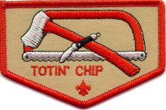  The Totin' Chip card is granted by  Troop 423 to Scouts who have demonstrated the proper procedures for proper use and understanding of wood tools.  Ver.02 01/13 |  | Read and understand woods tools use and safety rules from the Boy Scout Handbook. (Pages 402-409)
 |  | Learn Knife, Axe and Saw safety
 |  | Demonstrate correct carrying and passing a pocket knife
 |  | Demonstrate how to sharpen a knife
 |  | Learn the correct care of a knife
 |  | Demonstrate how to whittle by making a fuzz stick
 |  | Demonstrate knife skills by making a tent peg
 |  | Learn the rules, use and set up of an axe yard
 |  | Learn the parts of an axe
 |  | Learn axe safety
 |  | Demonstrate correct carrying and passing of an axe
 |  | Demonstrate the “contact method”
 |  | Demonstrate the correct way to sharpen an axe
 |  | Demonstrate proper use of a camp saw

Totin' Chip
- Read and understand woods tools use and safety rules from the Boy Scout Handbook.
- Demonstrate proper handling, care, and use of the pocketknife, axe, and saw.
- Use knife, axe, and saw as tools, not playthings.
- Respect all safety rules to protect others.
- Respect property. Cut living and dead trees only with permission and good reason.
- Subscribe to the Outdoor Code.
Totin' Chip Privileges:
The Scout's "Totin' Rights" can be taken from him if he fails in his responsibility.
Troop 423 follows a “3-strikes” rule for Totin’ Chit. If a major safety violation occurs, or unsafe usage ends in bodily injury, the Scout's tool-use privilege may be revoked immediately and indefinitely.

Instructor |  | Student |  | Date Completed
When completed return this form to an adult leader.
The Totin' Chip card is granted by Troop 423 to Scouts who have demonstrated the proper procedures for proper use and understanding of wood tools.
Use this card to teach the requirements of Firem’n Chit

Complete the Totin’ Chip form and return it to an adult leader

Safety Rules
- When not using a blade keep it closed.
- Use only sharp clean blades, they are less likely to slip.
- Make sure no one is in your blood circle.
- Don't strike a knife with another tool or pry with it.
- Obey school regulations that prohibit carrying knives.

Blood Circle
The blood circle is an area the length of your arm around and above you that is the distance you can reach with a knife when using it to keep others safe.
To show the distance, hold a CLOSED knife in your hand and slowly make a circle around and above you in the air. That area is your blood circle.

The pocketknife
- When carrying and passing blades, keep them closed
- When passing a blade, before you let go the other person acknowledges by saying 'thank you', or ‘got it’
- When using a pocketknife cut away from yourself, so if a blade slips you won’t be injured.
- Always use the knife with control to minimize injuries.
- If you accidentally drop an open knife, never try to catch it. Quickly step back and wait until it fails to pick it up. Before you use it again, always inspect the knife and blade for any damage.

Sharpening a knife
Keep the back of the blade raised about 15 degrees and cut into the stone.
If you have an official Boy Scout or Swiss Army knife, you can approximate the correct angle if you rest the back edge of the blade on two stacked pennies. Another trick is to set the blade flat on the stone and adjust a bright light directly overhead. Slowly raise the back of the blade until you can just see a shadow.
Take about six strokes along the length of the knife on one side of the stone, then turn the blade over and repeat the process.
If you sharpen only one area of the blade, over time it will become uneven.
Care of a knife
- Keeping the knife clean and dry will help prevent rust and keep the knife from getting “tight”.
- If a knife has become wet, be sure that it is completely dried. If possible, rub a thin coat of oil on the metal parts to help prevent rust.
- Never clean the knife in a dishwasher.
- If cutting food, clean knife both before and after use.

Making a fuzz stick.
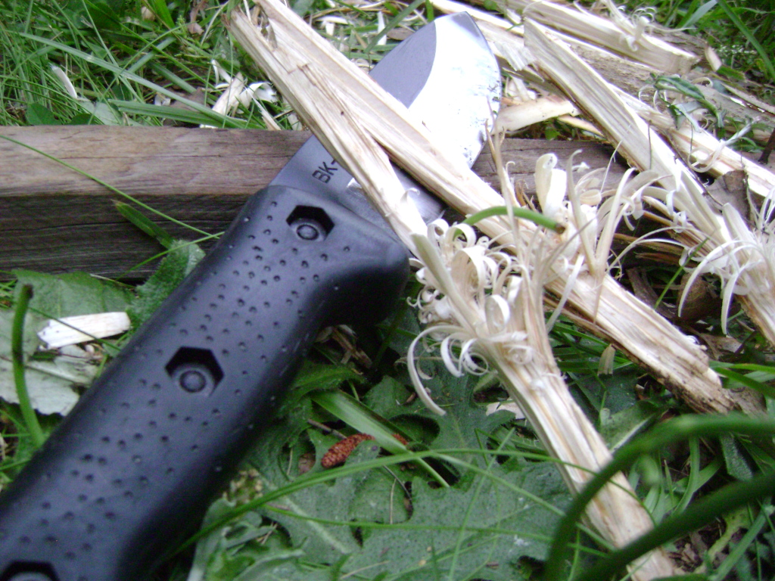
Find a stick about ½ to -1 inch thick.
Cut slices into the side of the stick, so that there are several shavings hanging off. Do not cut these shavings off of the stick.
These shaving are the part that is supposed to be lit since they are smaller than the actual stick and thus easier to burn. When there are enough fuzz sticks lit, the heat from all of the shavings will ignite the rest of the stick(s).

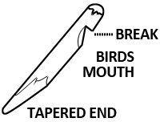
Making a tent peg
Find a stick about an inch thick and 9 inches long.
Taper the stick at the end so it can easily go into the ground.
On the top third of the stick (the other end from the taper) cut a birds mouth by first cutting a break about 1/3 the way through the stick. Using the break as a guide, cut the notch into the break taking small bites in the wood at a time. This should take about 5-10 cuts to complete the bird’s mouth.
The birds mouth is complete when it can comfortably catch a tent rope without slipping off.

Axe Yard
- An axe yard is a safe area for chopping and cutting.
- To alert everyone to the axe yard an area is roped off with brightly colored rope.
- Your axe yard should be large enough to provide the space you need to work. Checking that you have clearance above as well as to the sides.
- There is only one person allowed in an axe yard at a time, a second person is allowed for training purposes.
- To enter an axe yard the person in the yard must give permission to enter.
- There is only one entrance to the axe yard.
- When finished, clean up the chips, bark & cutting debris.
- Keep a chopping block in the axe yard for chopping and cutting and to protect your blades.

The parts of an Axe

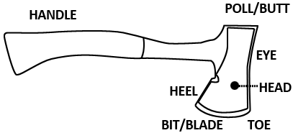
Safe Axe Use
- Wear closed toed shoes with a tread that allow you to keep your footing & protect feet in case of an accident
- Use a chopping block so that when you cut through, the blade will hit the wood of the block, not the ground.
- Keep an axe "buried" in a chopping block in the axe yard between uses and before putting it away.
- Never chop into the ground. Rocks can break axe blade.
- Sheath the axe until ready to use.
- Use a safe axe. Make sure the head is tight; handle sound; blade is sharp.

Carrying and Passing an Axe
- Hold an axe handle towards other person. If there is no sheath, don't pass with point or edge inside your hand.
- Carry an axe at your side with one hand, the blade turned out from your body. If you stumble, toss the axe away from you as you fall.
- Never carry an axe over your shoulder.

The “contact method”
Contact chopping is a safe method for cutting sticks and small firewood pieces.
You keep the axe blade in contact with the wood you want to chop and strike the chopping block with the axe and wood together.
If done correctly, the axe will end up buried in the wood so that twisting the axe and wood will split the wood the rest of the way.

How to sharpen an Axe
Keep your axe sharp with file 8 or 10 inches long. The lines across the face of the file are the teeth. They angle away from the point, or tang. A sharp file will be a drab gray color. A silvery shine means a file has broken teeth that won't sharpen very well.
Make sure to have a safety guard on a file when sharpening, usually this is a plastic coffee can top.
Whenever you sharpen with a file, wear leather gloves to protect your hands.
Brace the axe head on the ground between a small log and two wooden pegs or tent stakes. Another Scout can help hold the axe handle steady.
Place file on the edge of the blade & push it into the bit. Use enough pressure so that you feel the file cutting axe metal.
Lift the file as you draw it back for another stroke. A file sharpens only when you push it away from the tang.
Dragging the file across the blade on the return will break off the teeth and ruin the file.
Sharpen with firm, even strokes. After you have filed one side of the bit from heel to toe, turn the axe around and do the other side.
NOTE: The black axe does not get sharpened!

Camp Saw
- Carry a saw with the blade turned away from your body
- Make sure that the wood is held firmly - if you use your hand, keep it well away from the blade.
- Start slowly, pulling the blade backward towards you until the blade is well into the wood. Then push and pull in a steady rhythm using the whole length of the blade.

The Outdoor Code
As an American, I will do my best to Be Clean in my outdoor manners. Be Careful with fire. Be Considerate in the outdoors. And Be Conservation-Minded.

