Firem’n Chit  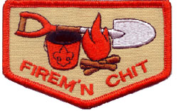  The Firem’n Chit card is granted by  Troop 423 to Scouts who have demonstrated the proper procedures for starting, maintaining and extinguishing lighting devices, cooking fires, campfires, & lanterns.  Ver.02 01/13 |  | Read fire safety rules in Scout Handbook (Pgs 301, 410-414) 00)
 |  | Learn fire safety
 |  | Learn safety and use of propane canisters
 |  | Learn safety and use of propane stove
 |  | Learn safety and use of propane lantern
 |  | Learn safety and use of ground fires
 |  | Learn common fire lays and their use
 |  | Learn common fire lays for cooking using wood
 |  | Learn use of charcoal
 |  | Learn common ways to use tinder
 |  | Prepare & light a fire
 |  | Discuss and put out fire using the cold out method
 |  | Understand and intend to live by the Outdoor Code

Firem’n Chit:
- I have read, understand and use fire safety rules from the Boy Scout Handbook.
- I will build a campfire only when necessary and when I have the necessary permits.
- I will minimize campfire impacts or use existing fire lays consistent with the principles of Leave No Trace. I will check to see that all flammable material is cleared at least 5 feet in all directions from fire (total 10 feet).
- I will safely use and store fire-starting materials.
- I will see that fire is attended to at all times.
- I will make sure that water and/or shovel is readily available. I will promptly report any wildfire to the proper authorities.
- I will use the cold-out test to make sure the fire is cold out and will make sure the fire lay is cleaned before I leave it.
- I will follow the Outdoor Code and the principles of Leave No Trace.

Firem’n Chit Privileges:
Firem’n Chit is an earned privilege that can be taken away if a Scout fails in his responsibility for the use of fire, or fire related tools or equipment.
Troop 423 follows a “3-strikes” rule for Firem’n Chit. After a 2 warnings a scout will need to re-earn his Firem’n Chit card. Scouts will receive 1 warning if he conducts a serious infraction with fire.

Instructor |  | Student |  | Date Completed
When completed return this form to an adult leader.
The Firem’n Chit card is granted by Troop 423 to Scouts who have demonstrated the proper procedures for starting, maintaining and extinguishing lighting devices, cooking fires, campfires, & lanterns
Use this card to teach the requirements of Firem’n Chit

Complete the Firem’n Chit form and return it to an adult leader

Fire safety
Read Fire Safety rules in your scout book (301, 410-414)
- Clear flammable vegetation 5 feet in all directions.
- Fire must be attended to at ALL times.
- Fire-fighting tools must be readily available.
- Fire must be cold to the touch before it is left.
- NEVER have a flame in a tent, including lit matches.
- Do not play with matches
- Do not wave or throw burning sticks.

Safety and use of propane canisters
- Propane is the main type of fuel used in Troop 423.
- Feel weight of full canister. Try to show full & empty.
- Explain how gas moves from canister.
- Never put canister in the fire.
- Propane may not work in cold weather & may ice up
- Stoves and Lanterns heat up quickly.
- Let equipment completely cool before putting away.
- Empty canisters can be put into the trash.
- Always attend a lit stove or lantern

Safety and use of propane stove
- Gas connections are “lefty tighty – righty loosy”.
- Make sure that all gas connections are hand tight.
- Position the stove in a stable location.
- Show how to light the stove
- Strike match before turning stove on.
- Show how to adjust the flame.

Safety and use of propane lantern
- Push down on canister when tightening but don’t force.
- Make sure that all gas connections are hand tight.
- Position the lantern in a stable location.
- Show how to light the lantern
- Strike match before turning lantern on.
- Show how to adjust the flame.

Use of Charcoal
- Charcoal is used with a grill, directly or Dutch oven.
- To prepare charcoal stack charcoal in a pyramid & light.
- Fast lighting charcoal is easer to use but burns out quicker. (It also smells like lighter fluid)
- Once lit, charcoal takes about 15-20 minutes until coals turn grey to be hot enough to cook on
- Each piece of charcoal is about 25 degrees. For a temperature of 325 degrees use 13 briquettes.

Tinder
- Used to start a fire & give kindling a chance to catch fire.
- Tinder is small flammable material like white dryer lint, wood shavings, birch bark, tinder fungus, pine resin, dry grass, and wood shavings.
- Leaves are not good kindling, creating lots of smoke.

Prepare & light a fire
- Fire should be lit using a maximum of 3 matches.
- Prepare and use any fire lay discussed.
- Fire must burn for 5 minutes. Additional kindling and fuel may be added.

Putting out fire using the cold out method
Follow in order:
- Spread the coals with a shovel or stick.
- Sprinkle water on the fire to begin to cool it. A big steam of water could cause burns through steam
- Continue with water or dirt. Stir the ashes and coals to ensure that they are completely out.
- The fire is out when the ashes and remains may be touched with the bare hand.
- This is called a Cold Out.

If water is scarce, use sand or dirt to put out the fire

The Outdoor Code
As an American, I will do my best to Be Clean in my outdoor manners. Be Careful with fire. Be Considerate in the outdoors. And Be Conservation-Minded
Safety and use of ground fires

- Campfires should only be built in locations where previous campfires have been built.
- Fires leave scars with long lasting effects. Fire destroys all of the minerals in the soil.
- Making a new fire pit is the last choice – and only used for heat. Not for “nice to have” fires.
- Some campgrounds require a permit to build an open fire. Know before you build the fire.
- Don’t build fires when conditions are too dry. Rangers will usually post a “No Fire” sign.
- A tight group of dry rocks should surround a fire ring to keep sparks & flammable material inside.
- Always ensure 5 gallons of water (or plenty of sand or dirt) and shovel is available by the fire.
- Ensure that fires are a safe distance from tents, tarps, ropes, propane and any other flammables.
- Once it’s lit it stays in the fire. This is a source of continual problems. Get caught – 1 strike.
- Fire must be attended at ALL times. If the fire is not going to be attended, it MUST be put out.

Common fire lays and their use
A fire needs 3 things to burn called a “Fire Triangle” - Oxygen, Fuel & Heat
There are 3 types of wood:
- Tinder: Dryer lint, wood shavings, birch bark, tinder fungus, pine resin, dry grass, wood shavings
- Kindling: Small pieces of wood up to the diameter of your finger
- Fuel: Various sizes of wood, larger than kindling.

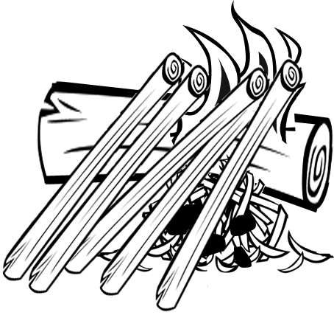 | 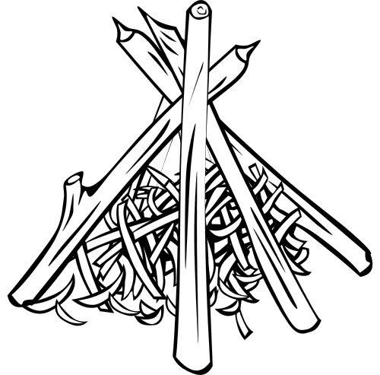 | 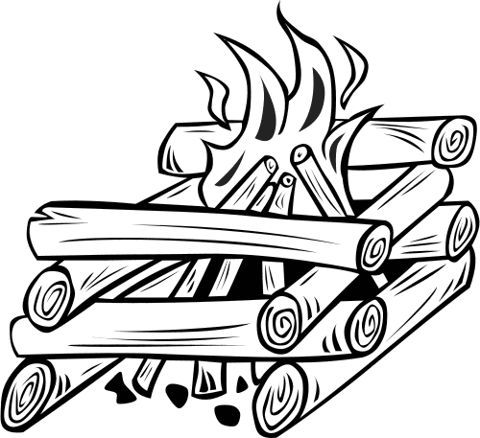
Lean-To | Teepee | Log Cabin
Start by placing a green "lean-to" stick in the ground at a slant or on a larger log.  Use a green stick because it will burn slower and maintain the Lean-To. | Start by placing a large handful of tinder in the middle.  Lean a circle of kindling around tinder. The tips should meet like a teepee.  Feed fire from down wind side. Add fuel after the fire is started. | Make a crisscross made from logs at the bottom. The smaller crisscross fire lay is made from branches on top.  Start fire at top with the smaller pieces of wood. As campfire progresses, it will light the bottom. Ideal council fire.
Common fire lays for cooking using wood
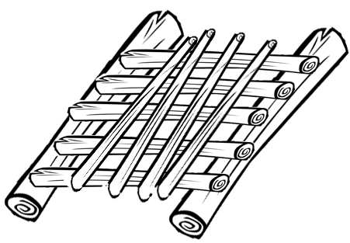 | 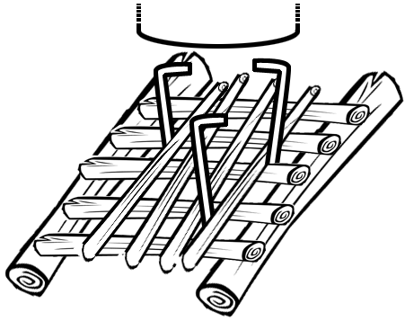 | 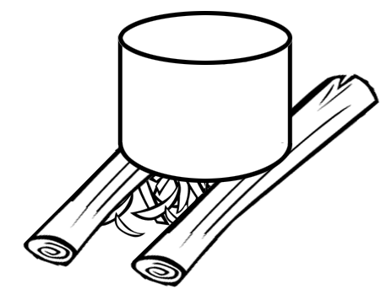
Criss-Cross | ThreePoint | Hunters
Used to boil water in a hurry.  Place 2 sticks (1-2”) parallel to each other about 1 foot apart.  Put tinder inside and place kindling sticks across the 2 supports a “little finger width” apart.  Continue with more crisscross layers. Increase thickness from layer to layer. | For a single pot or pan.  Stick 3 metal stakes into the fire lay before you start the fire then build a Crisscross Fire.  The metal tent stakes will hold a frying pan. | Place two logs on the ground.  Separate the logs according to the width of your pot.  Put a handful of tinder and kindling against the logs.  Build up the fire lay with thicker and thicker fuel then ignite the tinder.

